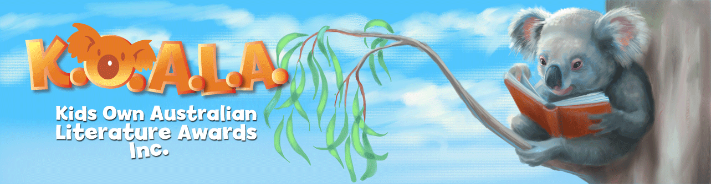
Suggested Children’s Australian Authors

A  - Randa Abdel-Fattah  - Deborah Abela  - Alexandra Adornetto  - Felice Arena  B  - Jeannie Baker  - Angelica Banks  - Tristan Bancks  - Graeme Base  - Catherine Bateson  - Michael Gerard Bauer  - Johanna Bell  - Aaron Blabey  - Cally Black  - Nick Bland  C  - Isobelle Carmody  - Brian Caswell  - Anna Cidor  - Margaret Clark  - Judith Clarke  - Matt Cosgrove  - Gary Crew  - Phil Cummings  D  - Justin D’Ath  - Garry Disher  - Anh Do  - Greg Driesse  - Ursula Dubosarsky  E  - Hazel Edwards  F  - Jules Faber  - Anna Fienberg  - Mem Fox  - Kate Forsyth  - Pamela Freeman  - Jackie French  - Sandy Fussell  G  - Susanne Gervay  - Libby Gleeson  - Morris Gleitzman  - Jane Godwin  - Bob Graham  - Mark Greenwood  - Andy Griffiths | H  - Richard Harland  - Wendy Harmer  - Christine Harris  - Tim Harris  - Sonya Hartnett  - Libby Hathorn  - Rosanne Hawke  - Jack Heath  - John Heffernan  - Peter Helliar  - Steven Herrick  - Leigh Hobbs  - Kylie Howarth  I  - Robert Ingpen  - George Ivanoff  J  - Paul Jennings  - Catherine Jinks  - Barry Jonsberg  K  - Victor Kelleher  - Stephen Michael King  - Sheena Knowles  L  - Kym Lardner  - Andy Lee  - Frané Lessac  - Alison Lester  - Gabrielle Lord  - Dave Luckett  M  - John Marsden  - Sophie Masson  - Heath McKenzie  - David McRobbie  - Geoffrey McSkimming  - Glenda Millard  - James Moloney  - Sally Morgan  - Chris Morphew  - Sally Murphy  - Belinda Murrell | N  - Deborah Niland  - D'Arcy Niland  - Garth Nix  - Lynette Noni  O  - Pixie O'Harris  - Narelle Oliver  - Wendy Orr  P  - Michael Panckridge  - Ruth Park  - Aura Parker  - James Phelan  - Boori Monty Pryor  - Felicity Pulman  R  - Sally Rippin  - Jennifer Rowe (Emily Rodda)  - James Roy  S  - R.A. Spratt  - Matt Stanton  - Briony Stewart  T  - Shaun Tan  - Lian Tanner  - Kate and Jol Temple  - Colin Thompson  - Jessica Townsend  W  - Michael Wagner  - Anna Walker  - Frances Watts  - Bruce Whatley  - Nova Weetman  - Nadia Wheatley  - Samantha Wheeler  - Margaret Wild  - Carole Wilkinson  - Mark Wilson  - Tony Wilson  - Tim Winton  - Patricia Wrightson  Z  - Claire Zorn  - Markus Zusak

